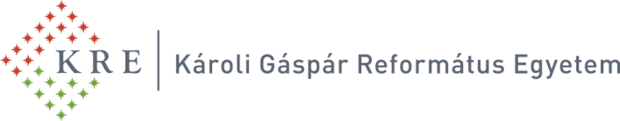
Bölcsészettudományi Kar
Művészettudományi és Szabadbölcsészeti Intézet

Kodály Culture in Hungary and Worldwide specialised postgraduate continuing education programme

launched by Károli Gáspár University of the Reformed Church in Hungary in the autumn term of academic year 2019/2020
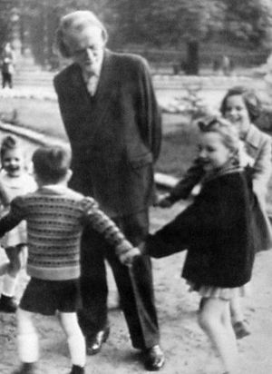
According to the educational concept used in the scope of this training programme, tradition and pedagogy, music and cultural knowledge, national and global cultures, folk music and classical music, arts and education, methodology and a special mindset of conceptual perspectives, theory and practice all play an equally emphatic role in the complex educational approach characterised by Kodály culture, and more specifically by the Kodály method. This educational approach covers more than a specific method and, in fact, even the very method applied involves more than a tactful pedagogical application of hand signs. The practical application of Kodály’s ingenious philosophy adopted for the purpose of this training programme offers a myriad of potentials so far unexplored, and holds several potentials inviting contemporary music teachers and educators to reconsider, revisit and further develop Kodály’s legacy.

Our specialised postgraduate continuing education programme does not replace the Kodály method based outstanding musical education used both in Hungary and worldwide but rather supplements and contextualises it in a wider framework of cultural and doctrinal theories. Our committed staff of university professors and guest lecturers, all boasting of international teaching experience, ensure the topmost quality and the highest level of training, which in turn empowers kindergarten, primary and secondary school teachers as well as educators of singing and music to structure their classes in a way that their teaching becomes colourful, varied and experiential by way of exploiting the educational, spiritual, identity-formation related and creativity-enhancing effects of musical education.

By integrating learning contents connected to European music-related arts, participants will be able to develop a broad spectrum of musical, pedagogical, art and cultural studies related knowledge, which will serve as a sound foundation for specialists working in public education, primary art education, diverse cultural, public cultural, and museum pedagogy institutions both in Hungary and in other countries.

The programme is offered both in English and Hungarian. The programme takes 4 terms to complete and requires the payment of a tuition fee.
Foreseeable date of the start of the programme: in the month of September 2019.

Designation of qualification awarded upon the successful completion of the correspondence programme: expert specialised in Kodály culture.

Minimum requirements concerning admission: degree awarded after the completion of a BEd programme and/or degree awarded after the completion of a BA-level programme in any of the fields of humanities, social sciences or arts.
Application deadline: 20 June 2019

Please, submit your application by filling in the form available at the following website: http://www.kre.hu/btkfelveteli.

For further information, please visit the following website: http://www.kre.hu/btk/index.php/kodaly-kultura-magyarorszagon-es-kulfoldon-szakiranyu-tovabbkepzesi-szak
You can also request further information by contacting our colleagues by phone or by e-mail at the following contact data:
phone: +36-30-962 5097, +36-1-483-2882
e-mail: sztretye.renata.monika@kre.hu; papp.zsuzsanna@kre.hu

